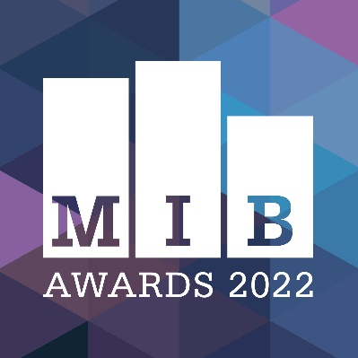
Merseyside Independent Business Awards
2022

Culture & Tourism Busines of the Year

BUSINESS NAME
CONTACT NAME
JOB TITLE
EMAIL
TEL
ADDRESS
NO OF EMPLOYEES
SOCIAL MEDIA HANDLES
BUSINESS WEBSITE ADDRESS
BUSINESS TYPE  (highlight as appropriate) | Sole Trader  Partnership  Limited liability company (LTD)  Limited liability partnership (LLP)  Other (please state):
COMPANY REG NUMBER
(If applicable)

Category guidelines

Eligible businesses include: theatres, museums, music venues, tour operators, tourism attractions, cultural attractions independent production companies – any business with a tourism offering.
If you have any queries regarding eligibility, please contact us on the email below.

Businesses entering must have headquarters based in Merseyside, Liverpool City Region (Liverpool, Wirral, Knowsley, St Helens, Sefton, Halton).

Businesses entering must be fully independent, free from outside control and be privately owned.

Supporting evidence, such as testimonials, photographs, business accounts information is encouraged. This must be no more than three sides of A4, and is to be emailed in PDF format along with completed entry form.

Judges will score each question out of five points, based on answer quality and clarity

The Merseyside Independent Business Awards takes place on Thursday, October 20 at Rum Warehouse, Titanic Hotel.

The full shortlist will be announced around a month prior to this.

All information and supporting evidence will be treated in the strictest confidence –information will be shared with MIB judges only.

Deadline for entry form submission is 5pm on Friday, August 12, 2022

Entries made after this date will not be submitted to judges.

Please submit your completed form & supporting evidence to info@mibawards.co.uk
If you have any queries, please email us on the above address

SMALL PRINT: This form will be treated with the utmost confidentiality. It will be seen by judges and not by any third parties. Following the awards, your form will be securely destroyed.

Q1 – Tell us about your business - what do you offer as a cultural or/and tourism organisation, and what makes your business special?  (300 words max) | Judge use only
Suggested considerations: What service do you offer? How long have you been established? Who are your founders / directors or key people? Where are you based? | /5

Q2 – How many guests / visitors have you welcomed in the past 12 months? How has this impacted on the culture and tourism offering of the city region?  (300 words max) | Judge use only
Suggested considerations: Have numbers increased? | /5

Q3 – How have you invested in your organisation in the past 12 months?  (300 words max) | Judge use only
Suggested considerations: Have you developed a new building? Recruited new staff? Invested in training? Have you launched a new product line or visitor attraction? Has your approach to marketing changed to target specific groups? Have you been able to create new partnerships? | /5

Q4 – What impact has your business had on the city region’s culture and tourism offering, and why should you be crowned the winner of Culture & Tourism Business of the Year 2022?  (300 words max) | Judge use only
Suggested considerations: Have you been able to attract a new group of visitors? Has your organisation added a new dimension to the city’s cultural landscape? | /5
Judge use only  Overall score | /20

